# Optimisation report

## Introduction

The purpose of this document is to optimise the movie database application by analysing the webpages of the application. Code optimization is any method of code modification to improve code quality and efficiency. A program may be optimized so that it becomes a smaller size, consumes less memory, executes more rapidly, or performs fewer input/output operations.

Optimization can be performed by automatic optimizers, or programmers. An optimizer is either a specialized software tool or a built-in unit of a compiler (the so-called optimizing compiler). Modern processors can also optimize the execution order of code instructions

## Performance tool used

### WebLOAD

Enterprise-grade load and performance testing tool for web applications. WebLOAD is the tool of choice for enterprises with heavy user load and complex testing requirements. It allows you to perform load and stress testing on any internet application by generating load from the cloud and on-premises machines. <https://www.youtube.com/watch?v=nffOrOtVvT0&feature=share>

## Summary

|  |  |  |  |  |  |  |  |  |  |  |
| --- | --- | --- | --- | --- | --- | --- | --- | --- | --- | --- |
| **Start** |  | 11/27/19 11:48 PM |  | **End** |  | 11/28/19 12:29 AM |  | **Duration** |  | 00:41:21 |

|  |  |  |  |  |
| --- | --- | --- | --- | --- |
| **Test passed** | **Max Virtual Clients** | 1 | **Total Throughput (MB)** | 3.84 |

|  |  |  |  |  |  |  |  |  |
| --- | --- | --- | --- | --- | --- | --- | --- | --- |
| **Total Errors** |  | 0 |  | **Total Warnings** |  | 0 |  |  |
|  |  |  |  |  |

|  |  |  |  |  |  |  |  |  |
| --- | --- | --- | --- | --- | --- | --- | --- | --- |
| **Failed Rounds** |  | 0 |  | **Total Rounds** |  | 5 |  |  |
|  |  |  |  |  |

|  |  |  |  |  |  |  |  |  |
| --- | --- | --- | --- | --- | --- | --- | --- | --- |
| **Total Failed Hits** |  | 0 |  | **Total Hits** |  | 79 |  |  |
|  |  |  |  |  |

|  |  |  |  |  |  |  |  |  |
| --- | --- | --- | --- | --- | --- | --- | --- | --- |
| **Total Failed TXs** |  | 0 |  | **Total TXs** |  | 38 |  |  |

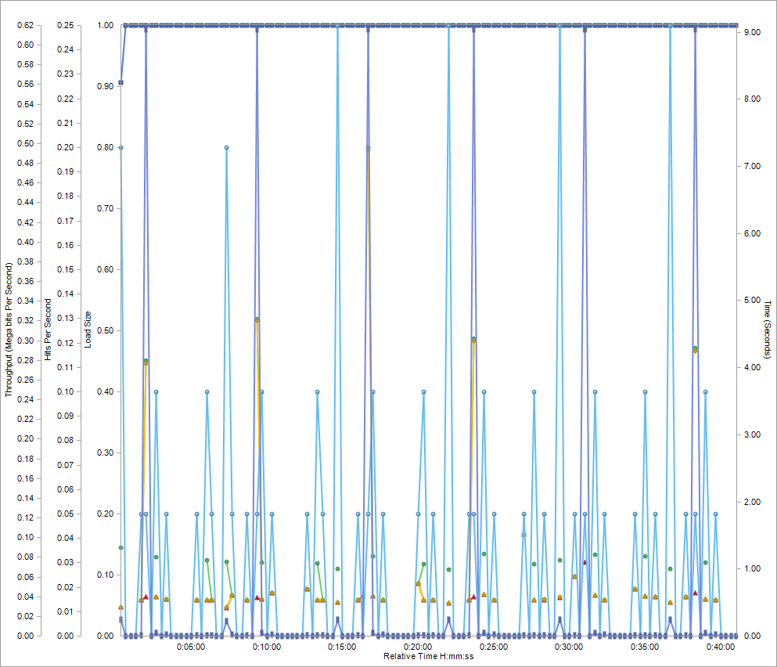

|  |  |  |  |  |  |  |  |  |
| --- | --- | --- | --- | --- | --- | --- | --- | --- |
|  | | | **Measurement Name** | **Min** | **Max** | **Average** | **StDev** |  |
|  |  |  | Load Size | 0.907 | 1 | 0.999 | 0.008 |  |
|  |  |  |  |
|  |  |  |  |
|  |  |  | Page Time | 0.533 | 9.057 | 1.468 | 1.775 |  |
|  |  |  |  |
|  |  |  |  |
|  |  |  | Time To First Byte | 0.425 | 1.514 | 0.602 | 0.174 |  |
|  |  |  |  |
|  |  |  |  |
|  |  |  | Response Time | 0.428 | 9.02 | 1.247 | 1.826 |  |
|  |  |  |  |
|  |  |  |  |
|  |  |  | Hits Per Second | 0 | 0.25 | 0.032 | 0.056 |  |
|  |  |  |  |
|  |  |  |  |
|  |  |  | Throughput (Mega bits Per Second) | 0 | 0.616 | 0.031 | 0.133 |  |
|  |  |  |  |
|  |  |  |  |

This chart displays the main performance indicators and changes in Load Size, over time:

- Load Size – The number of Virtual Clients running during the last reporting interval.

- Page Time – The time it takes to complete a successful upper level request, in seconds.

- Time to First Byte – The time it takes from when a request is sent until the Virtual Client receives the first byte of data.

- Response Time –The time it takes the SUT to send the object of an HTTP request back to a Virtual Client, in seconds.

- Hits Per Second – The number of times the Virtual Clients made an HTTP request, divided by the elapsed time.

- Throughput – The average number of Mega bits per second, transmitted to the Virtual Clients running the Agenda.

**Slowest Transactions**

|  |  |  |  |  |  |  |  |
| --- | --- | --- | --- | --- | --- | --- | --- |
| **Transaction Name** | **Transaction Time** | | | | | | |
| **Count** | **Avg.** | **Percentile 90.0%** | **Max** | **Min** | **Std Dev** | **TPS** |
| Transaction Add User | 5 | 126.422 | 127.091 | 127.091 | 126.113 | 0.344 | 0.002 |
|  |  |
| Transaction Remove User | 5 | 57.435 | 57.470 | 57.470 | 57.358 | 0.040 | 0.002 |
|  |  |
| Transaction Log In Admin | 5 | 39.423 | 39.508 | 39.508 | 39.383 | 0.048 | 0.002 |
|  |  |
| Transaction Frequent Search | 6 | 32.603 | 32.665 | 32.665 | 32.531 | 0.052 | 0.003 |
|  |  |
| Transaction Show All Movies | 6 | 31.640 | 35.050 | 35.050 | 30.097 | 1.865 | 0.003 |
|  |  |